
SEAP Airport Simulation

User Guide
Group 43
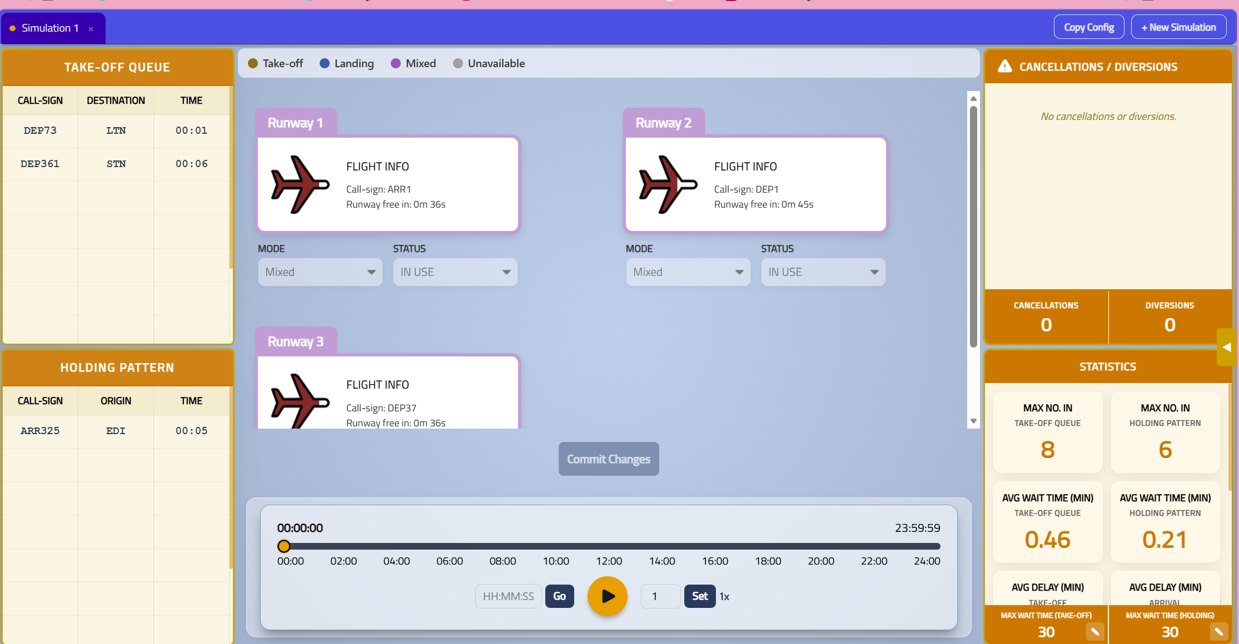

Table of Contents
1 Getting Started
2 Start Page
3 Simulation Page Overview
4 Runway Cards
5 Takeoff Queue & Holding Pattern
6 Timeline Controller
7 Cancellations & Diversions
8 Statistics Panel
9 Arrivals & Departures Sidebar
10 Simulation Tabs
11 Making Configuration Changes
12 Troubleshooting

1. Getting Started

Prerequisites
- Node.js (v16 or later) for the React frontend
- Python 3.10+ for the FastAPI backend
- A modern web browser (Chrome, Firefox, Edge)

Running the Application
- Start the backend: Remain in the SEAP outer directory and run:
uvicorn api.app:app --host 0.0.0.0 --port 8000 --reload
- Start the frontend: From a different terminal, navigate to the ReplaySys directory and run:
npm install && npm start
- Open your browser and navigate to http://localhost:5173/ (or the port shown in your terminal).

2. Start Page

The Start Page is the first screen you see when launching the application. It collects three parameters to configure your simulation.
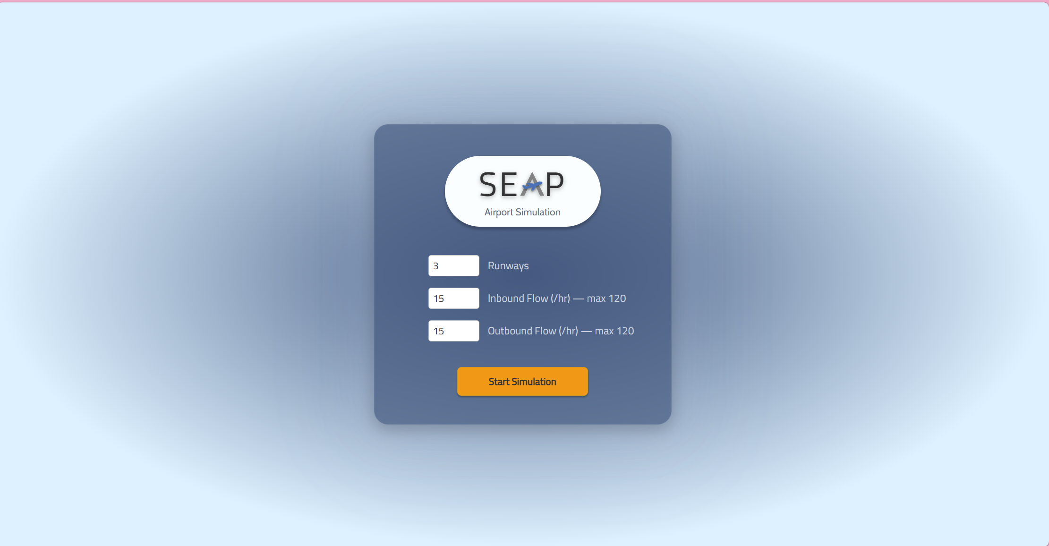
Parameter | Description | Range
Runways | Number of runways at the airport | 1–10
Inbound Flow | Incoming planes per hour | 0–(numRunways×40)
Outbound Flow | Departing planes per hour | 0–(numRunways×40)

To start a simulation:
- Enter your desired values using the number inputs (type or use the arrows).
- Click Start Simulation.
- The application will switch to the Simulation Page automatically. A loading indicator appears while the backend processes all 86,400 ticks (one full 24-hour day).

3. Simulation Page Overview

The Simulation Page is divided into several areas:
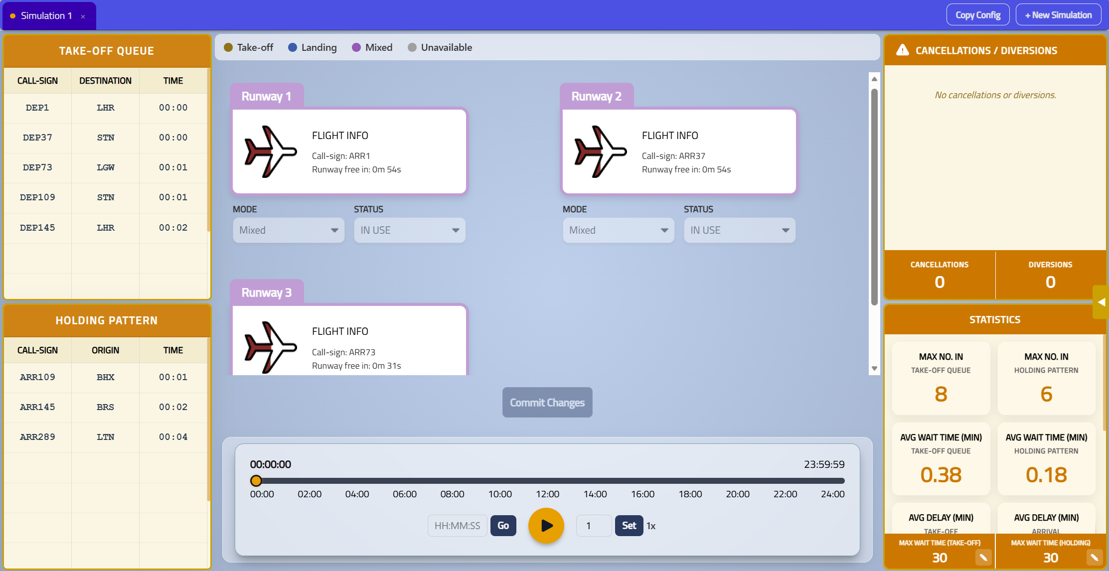
- Left sidebar: Takeoff Queue and Holding Pattern tables
- Centre: Runway legend, colour-coded Runway Cards grid, Commit Changes button, Timeline controller
- Right sidebar: Cancellations/Diversions feed and Statistics panel
- Sliding panel: Arrivals & Departures (toggled via the arrow button on the right edge)
- Simulation Tab: At the top of the page

4. Runway Cards

Each runway is displayed as a colour-coded card in the centre grid.
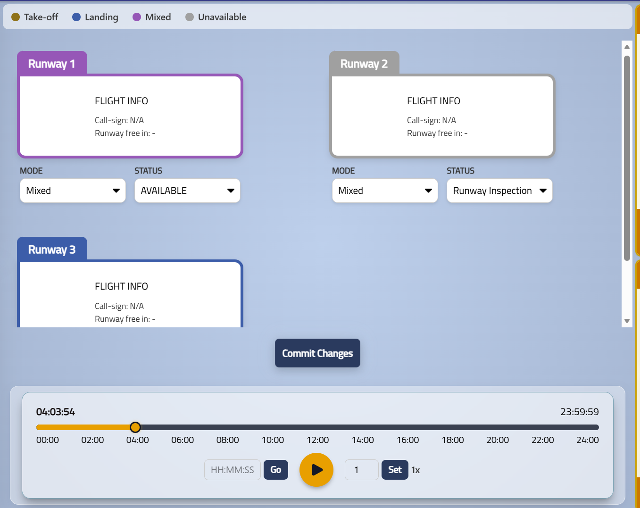
Colour Key
Colour | Meaning
Gold | Take-off mode
Blue | Landing mode
Purple | Mixed mode
Grey | Unavailable
Muted versions of these colours appear when a runway is currently in use (i.e., a plane is on it).

Card Information
Each card shows:
- Runway name (in the coloured tab)
- Plane icon with fuel-level indicator (5 tiers)
- Call-sign of the plane currently on the runway
- Runway free in countdown timer
Hover Details
Hover over any runway card to see a detailed popup with callsign, operator, route, altitude, ground speed, fuel remaining, and emergency status.
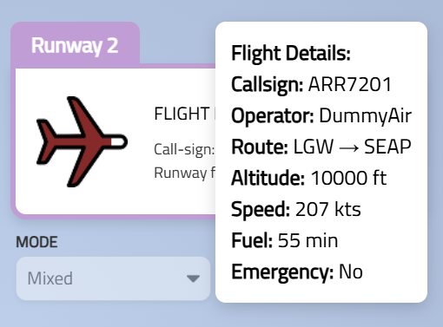
Mode & Status Dropdowns
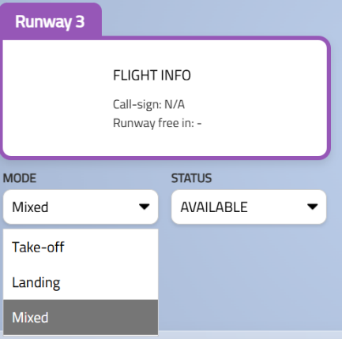
Mode determines what type of planes can use the runway: Take-off, Landing, or Mixed.
Status determines runway availability: Available, Runway Inspection, Snow Clearance, or Equipment Failure.
Note: Dropdowns are locked during playback and when a runway is in use. Pause the simulation to make changes.

5. Takeoff Queue & Holding Pattern

These two tables on the left sidebar show planes waiting for a runway.
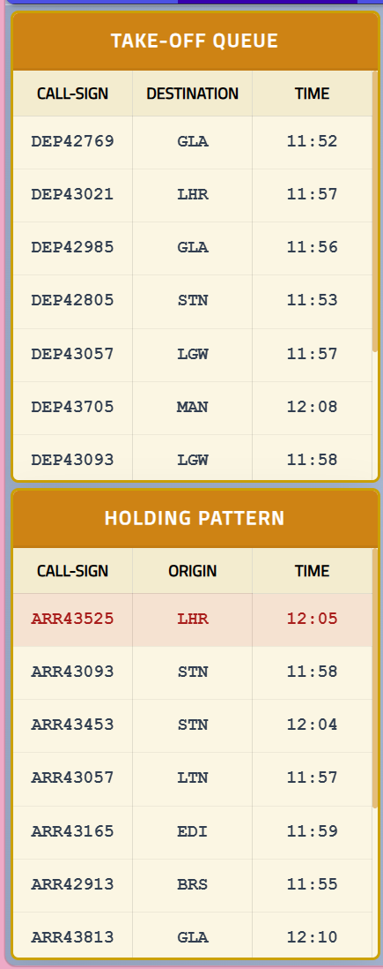
Takeoff Queue
Displays outbound planes waiting on the ground. Columns: Call-sign, Destination, Time.
Holding Pattern
Displays inbound planes circling overhead. Columns: Call-sign, Origin, Time.
Emergency Toggle (Holding Pattern only)
Hover over any row in the Holding Pattern table to reveal a popup with an emergency toggle switch. This allows you to manually declare an emergency for a specific aircraft, which prioritises it for landing.
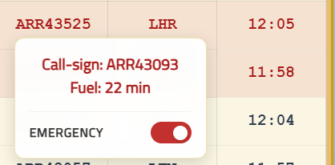
Note: The emergency toggle is only available for planes in the holding pattern (airborne planes), not the takeoff queue. It is disabled during playback — pause the simulation first.

6. Timeline Controller

The timeline at the bottom of the centre panel controls simulation playback.
Slider
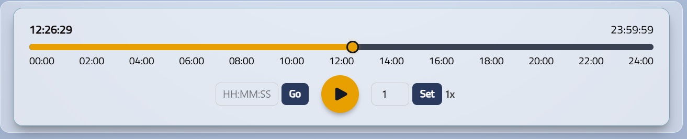
Spans a full 24-hour day (00:00:00 to 23:59:59). Drag to go to any point in time instantly. 2-hour tick marks provide orientation.
Play / Pause Button
Click to start or pause playback. All UI components update in real time as the simulation advances.
Jump to Time
Type a time in HH:MM:SS, HH:MM, or raw seconds. Press Enter or click Go to jump to that exact moment.
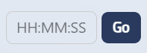
Speed Multiplier
Type a speed value (1–100) in the number input and click Set to apply. The current speed is displayed as a label (e.g., "8x"). At 1x speed, the simulation plays in real time. At 10x speed, it runs 10 ticks per second.
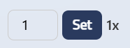

7. Cancellations & Diversions

The top-right panel shows a live feed of cancellation and diversion events.
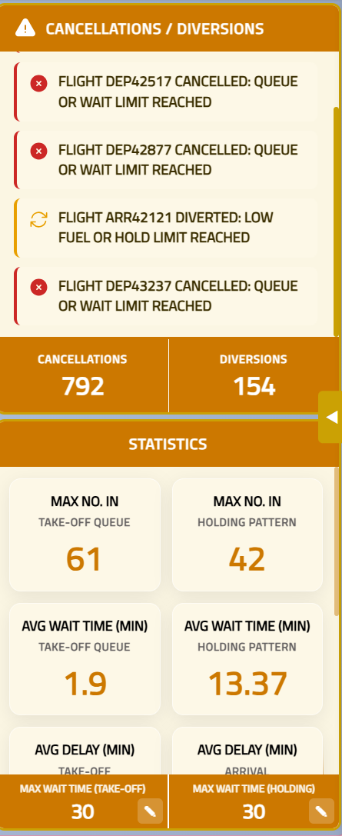
- Scrollable event list showing the most recent events with type-specific icons
- Red X icon for cancellations, amber arrow icon for diversions
- Footer counters showing cumulative totals at the current tick
- The list auto-scrolls to the latest event during playback

8. Statistics Panel

The bottom-right panel displays aggregated simulation metrics.
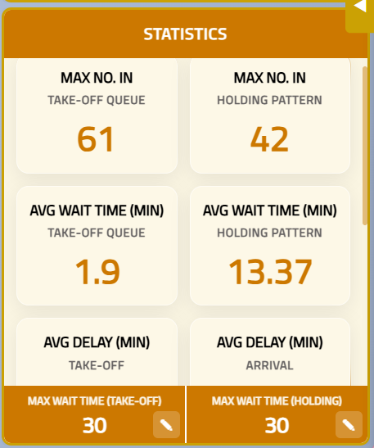
Metric | Description
Max No. In Takeoff Queue | Peak number of planes waiting to depart
Max No. In Holding Pattern | Peak number of planes waiting to land
Avg Wait Time (Takeoff) | Average time a departing plane waits in queue
Avg Wait Time (Holding) | Average time an arriving plane waits in pattern
Avg Delay (Take-off) | Average departure delay
Avg Delay (Arrival) | Average arrival delay
Max Delay (Take-off) | Worst-case departure delay
Max Delay (Arrival) | Worst-case arrival delay
Total Cancellations | Cumulative flights cancelled (updates per tick)
Total Diversions | Cumulative flights diverted (updates per tick)

Configurable Thresholds
At the bottom of the Statistics panel are two editable fields:
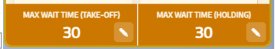
MAX WAIT TIME (TAKE-OFF): Maximum time (minutes) a departing plane can wait before being cancelled.
MAX WAIT TIME (HOLDING): Maximum time (minutes) an arriving plane can hold before being diverted.
To edit a threshold:
- Pause the simulation.
- Click the edit button (✎) next to the value.
- Type a new number.
- Click apply (✔) to confirm.
- Click Commit Changes to send the update to the backend.

9. Arrivals & Departures Sidebar

A sliding panel on the right edge of the screen, toggled by the arrow button.
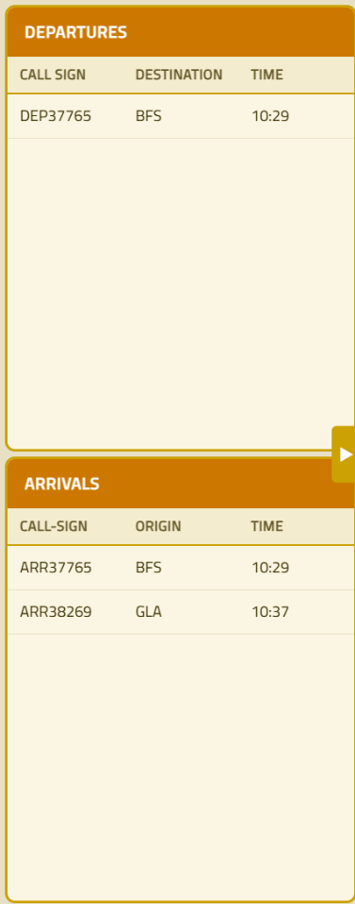
Shows planes currently on runways, split into two tables:
Departures: Planes taking off (origin = SEAP)
Arrivals: Planes landing (origin ≠ SEAP)
Each entry shows the call-sign, destination/origin, and scheduled time.

10. Simulation Tabs

The tab bar at the top allows you to manage multiple simulations side-by-side.
Tab Types
Root simulations (e.g., "Simulation 1", "Simulation 2"): Created via the Start Page with different input parameters.
Config copies (e.g., "Simulation 1.1", "Simulation 1.2"): Created by committing configuration changes, which updates the simulation into a new tab.
Tab Indicators
- Green dot: Simulation is currently playing
- Amber dot: Simulation is paused
Tab Actions
Button | Action
Copy Config | Deep-copies the active simulation into a new tab for experimentation
+ New Simulation | Returns to the Start Page to create a fresh simulation
× (on tab) | Closes that tab (auto-switches to nearest remaining tab)

11. Making Configuration Changes

The simulation supports mid-run configuration changes. Here is the complete workflow:
Step-by-step
1. Pause the simulation using the play/pause button.
2. Make your changes (any combination of):
- Change a runway’s mode or status via the dropdown menus
- Toggle emergency on a plane in the holding pattern
- Edit max wait time thresholds in the Statistics panel
3. The Commit Changes button turns blue when there are pending edits.
4. Click Commit Changes.
5. The application sends your changes to the backend, which re-runs the simulation from the point of change.
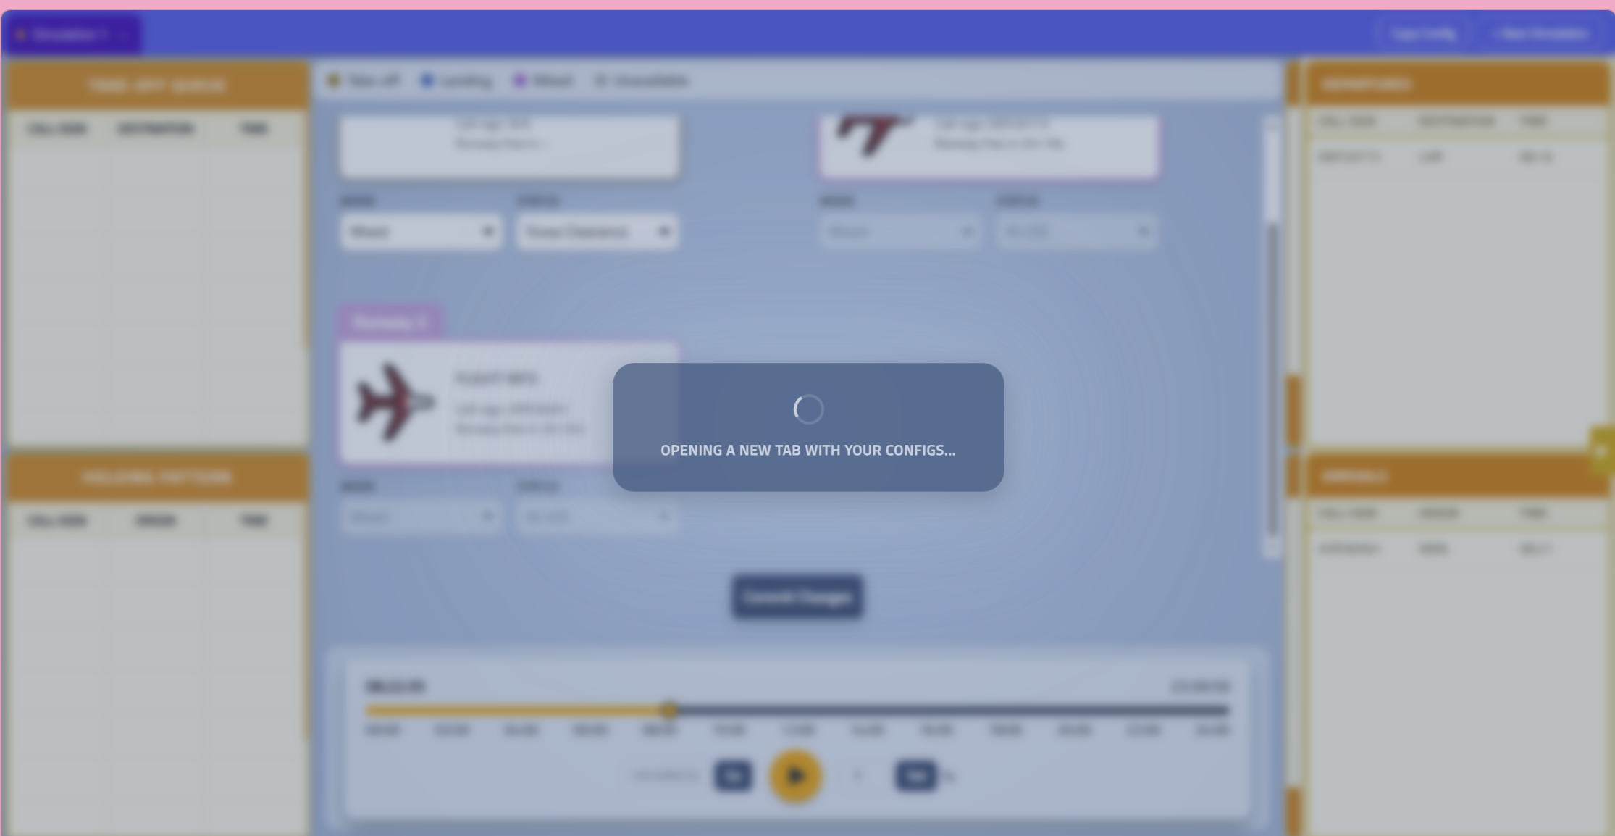
6. A new tab opens with the updated simulation results.
7. The original tab is preserved — you can switch back to compare.
Important Notes
- You cannot make changes while the simulation is playing — dropdowns, toggles, and config fields are locked.
- The Commit Changes button is greyed out when playing or when there are no pending edits.
- Each commit creates a new backend simulation version (e.g., 1.0 → 1.1), so you never lose your original data.
- Multiple changes can be batched into a single commit.

12. Troubleshooting

Issue | Solution
App won’t start | Ensure both the backend (port 8000) and frontend (port 3000) are running. Check terminal for errors.
Simulation doesn’t load | Verify backend connectivity. The loading indicator should appear; if not, check the browser console.
Dropdowns are locked | Pause the simulation first. Controls are disabled during playback.
Commit Changes greyed out | Either no changes have been made, or the simulation is playing. Pause and make at least one edit.
Speed input not working | Enter a value between 1 and 100, then click Set.
Emergency toggle missing | Only available in the Holding Pattern table, not the Takeoff Queue. Hover to reveal.

